1. 
2. Another strategy to prevent **race condition** & **visibility** problem is to restrict multiple threads to access shared resource at the same time.   
   It is called **Synchronization**. So we have to synchronize/co-ordinate multiple threads accessing same object.  
   It is done using **locks.**
3. So we put a lock on a block of code and internally JVM ensures that only one thread access the code at a time. But in reality, the code is executed sequentially.   
   **Real Life Example**: Hotel Room. Only one guest can be in that room. When he gets the key, locks the door and other can’t enter until that guest checks out.
4. 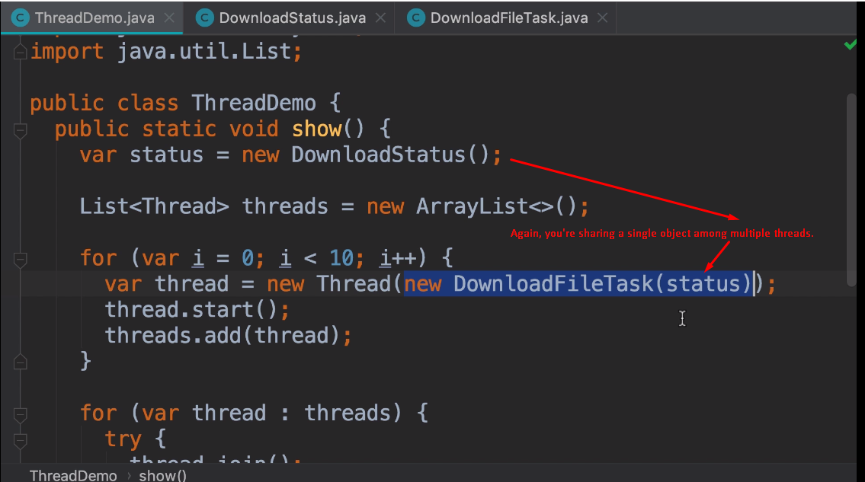
5. 